**Project title: analysis of trends in stock market**

**Team Name: Real data hub**

|  |  |
| --- | --- |
| **Team member Name** | **SRN** |
| KIRAN BS | PES2UG19CS186 |
| KAUSHIK T KUNDUR | PES2UG19CS179 |
| Chaithanya M P | PES2UG19CS095 |
| BHARAT K NAIK | PES2UG19CS086 |

1. **Dataset Name and Description.**

Name: - STOCK EXCHANGE DATA

DESCRIPTION: - Daily price data for index tracking stock exchange from all over the world. The data was all collected from yahoo finance ,which had several decades of data available for most exchanges. Price are quoted in terms of national currency of where each exchange is located.

1. **Problem statement**

Daily index price for multiple stock exchanges and analyzing.

1. **EDA and Visualization**

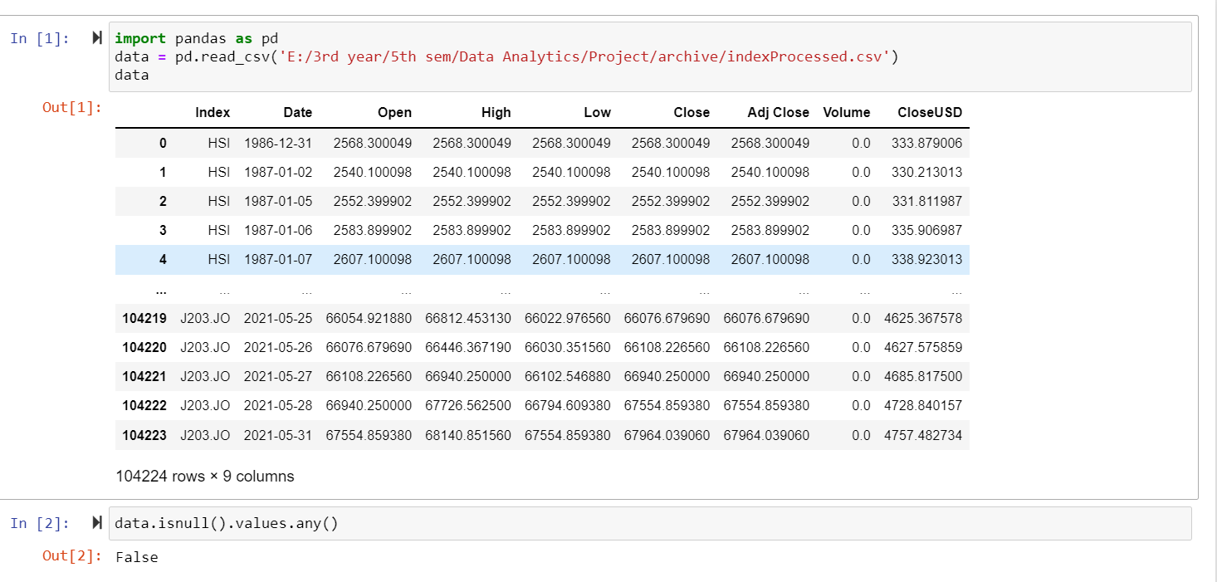

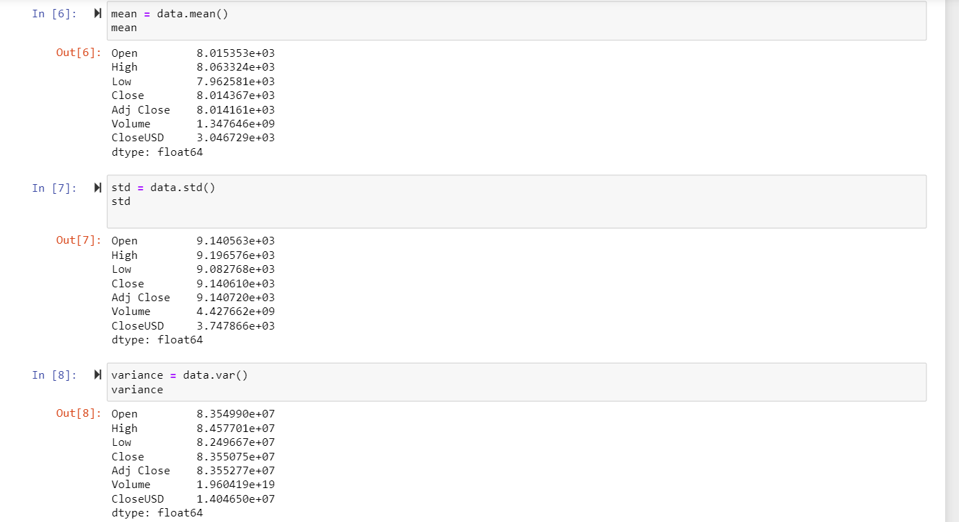

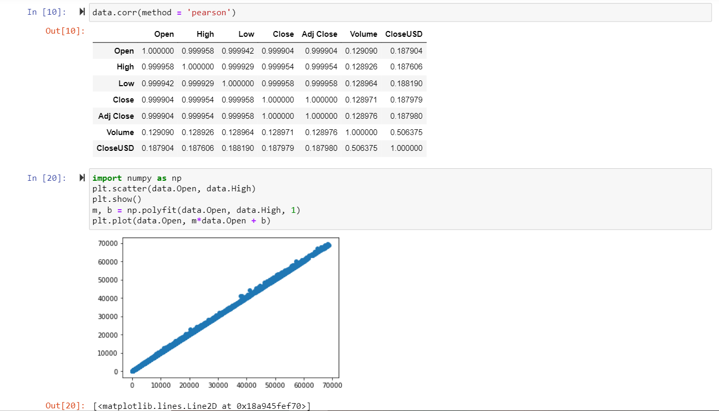

#We can see very high levels of correlation between the values of the dataset

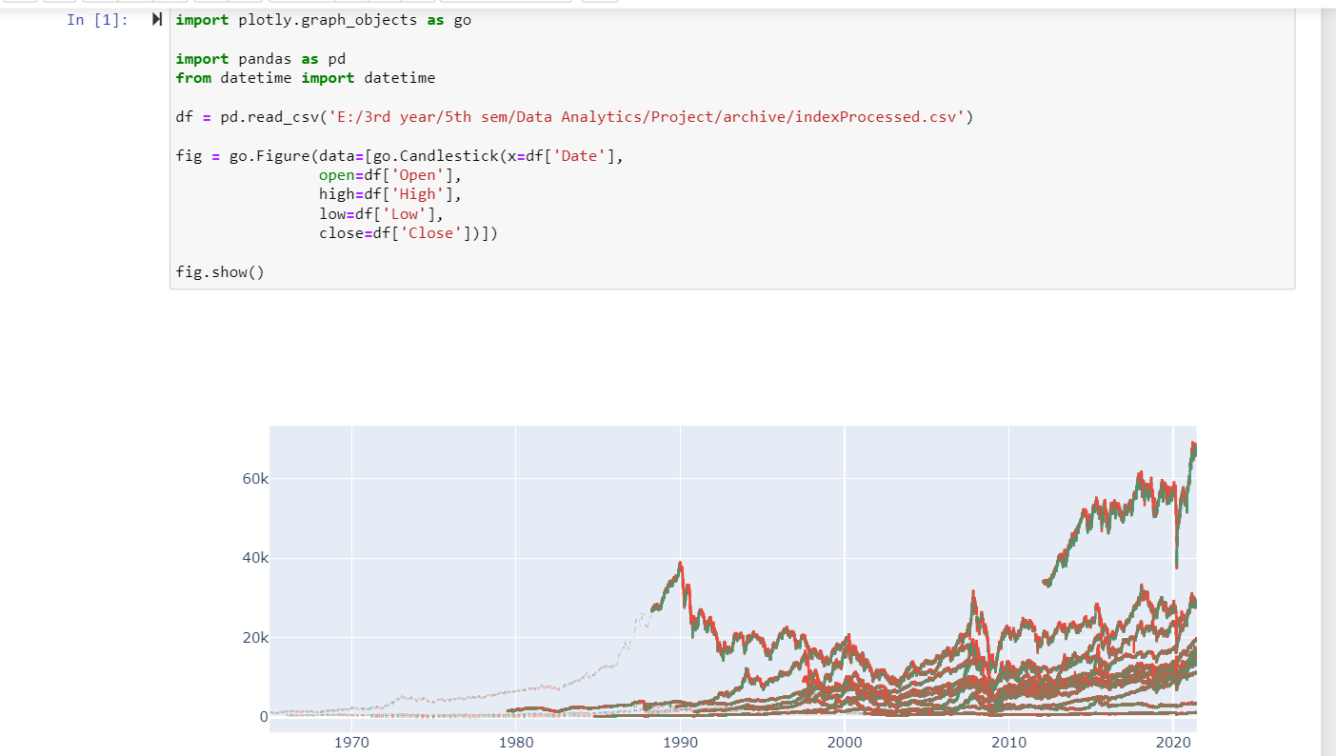

Moving time average graph that shows all the trends and variations in the data, i.e., the changes in the value of stocks as time has progressed

**Some important points regarding our dataset:**

* Our dataset has 9 attributes and approx. 1 lakh rows.
* Our dataset has no outliers and missing data as shown in the screen shots of our EDA above.
* We don’t have any incomplete or inconsistent or duplicate data in our dataset, it’s a clean dataset that we have found.
* When we checked for the correlation between the attributes of the dataset, it was found that the attributes are highly correlated with each other, and with my assumptions I can claim that those correlation numbers are spurious.
* In our dataset, no PCA (dimensionality reduction) was required for it to be processed easily.
* From our graph we can easily draw conclusions about the data present that the price of stocks, may go down or up over a course of a month, but there is a definite annual increase in the price of the stock, which is clear from the candlestick graph that’s been plotted above.

1. **Link for google sheet**

[**https://docs.google.com/spreadsheets/d/1OdOuv71A7yiWpDe9ebe9ALsiFCg5ox6BzZhYuFUbQTM/edit?usp=sharing**](https://docs.google.com/spreadsheets/d/1OdOuv71A7yiWpDe9ebe9ALsiFCg5ox6BzZhYuFUbQTM/edit?usp=sharing)

1. **Literature Survey (Summarize)**

[**https://drive.google.com/file/d/1KAJcyss-PlQ6ZQ-TbmIlzVHLQvN8YUC7/view?usp=sharing**](https://drive.google.com/file/d/1KAJcyss-PlQ6ZQ-TbmIlzVHLQvN8YUC7/view?usp=sharing)

1. **Your Plan:**

**With the dataset we have chosen, we intend to Plot regression models (SLR or MLR) and determine the probable values of the stock prices in the future, Which should be comparatively simpler given the high levels of correlation between the different parameters in the dataset**

1. **References**

<https://www.kaggle.com/mattiuzc/stock-exchange-data>